**Quora Duplicates Question Detection**

**Rishab Ghanti**

[**rishabrghanti@gmail.com**](mailto:rishabrghanti@gmail.com)

**Contents:**

1. **Definition**
2. Project Overview
3. Problem Statement
4. **Analysis**
5. Data Exploration
6. **Definition:**

1.1 Project Overview

Quora is a very famous platform (website and Android app) all over the world where questions can asked by anyone in the community which are answered by Quora’s 100 million monthly active users. There are different platforms like *StackOverFlow*[1]*, Yahoo! Answers*[2]*, WikiAnswers*[3]etc. for different domains but Quora[5] is by far the most popular general question-answer platform.

Due to its huge user base, it is expected that many users ask questions structured differently but having the same meaning. For example, the questions ‘What is the population of USA’ and ‘how many people live in USA’ are duplicates. Marking both these as duplicates and showing users one version of the question with the correct answer will allow users to get answers to their questions quickly and giving them more value.

1.2 Problem Statement

The goal of this project is to identify if a question pair is duplicate, i.e. the question pair has the same meaning. This is a natural language processing problem which is a popular field in Artificial Intelligence.

For example, we have a question pair as follows:

* How much does a Tesla model S cost?
* What is the cost of a Tesla model S?

We know that these 2 questions mean the same thing and will have the same answer. Hence the system will flag this pair as a duplicate.

To build such a mechanism in place I did the following steps:

1. Downloaded the Quora dataset and did some pre-processing on it to get a better understanding of it.
2. Split the dataset into 90% as training set and 10% as testing set.
3. Further split the training set into 10% as validation set and used the remaining data to train the model.
4. Extracted usable features from the sentences to feed to the model.
5. Using the training data trained a few models with different parameters to be able to recognize duplicate and non-duplicate pairs.
6. Tested these models and picked the one with the best score.

1.3 Metrics:

After exploring the data set I see that the dataset has 36.91% of positive entries whereas it has 63.08% of negative entries Since the dataset is unbalanced, the metric that I plan to use and will best suit this application to determine the accuracy of a model is F-score:

$$F=2*\left(\frac{precision*recall}{precision+recall}\right)$$

precision – number of positive results divided by the number of positive results returned by the classifier

recall – number of correct positive results divided by the number of all relevant samples (all relevant samples that should have been identified as positive)

2.2 Data Visualization:

2.2.1 Class Distribution

Below is a graph explaining the class distribution of duplicates and non-duplicate pairs.

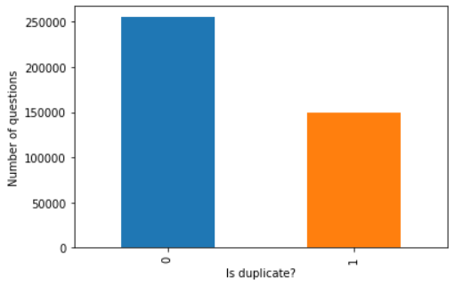

2.2.2 Word Count Difference

In this section we will discuss how the word count difference influences if a question is a duplicate or not.

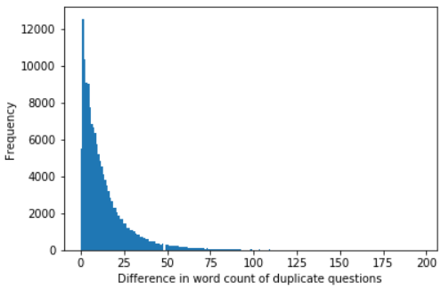

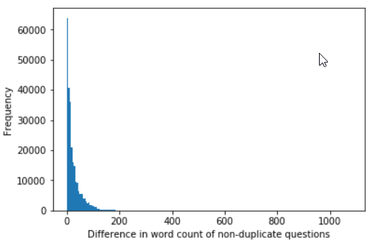

Observation from the above figures:

1. For duplicates, the word count tapers smoothly.
2. For non-duplicates, there is a sharp decrease In the 2nd bin.
3. There are question pairs that have word count difference 75 and above and are still duplicates, hence I conclude that a simple bag of words model will not work for this dataset.

2.2.3 Jaccard index

I have considered the bag of words model as a baseline model. The Jaccard index formula is:

$$J\left(A,B\right)=\frac{No. of common words in question1 and question2}{No. of unique words in question1 andquestion2}$$

where A and B are words in the questions and hence the equation can also be written as

$$J\left(A,B\right)=\frac{A∩B}{A∪B}$$

Using the above formula I concluded the following:

1. For duplicates, Jaccard similarity is like a gamma distribution. Jaccard is bad at predicting if a question pair is duplicate or not.
2. For non-duplicates, Jaccard similarity is again a gamma distribution but. Jaccard is bad at predicting if a question pair is duplicate or not.

2.3 Algorithms and Techniques

2.3.1 Feature Extraction

The inputs to the algorithm are 2 strings of variable length. After the input has been word-tokenized (split into individual words) there are primarily two ways in NLP (Natural Language Processing) using which features can be extracted. As explained below.

**Bag of words**

Here, every word is assigned a unique number. Hence the input now is a one-hot encoded array of numbers representing those words.

Consider a text corpus having the words ‘today’ and ‘tomorrow’. The word ‘today’ will be assigned the number 0 while ‘tomorrow’ will be assigned 1. Hence in one-hot encoded representation the word ‘today’ would be represented as [1 0] and ‘tomorrow’ would be [0 1].

Hence the number of features extracted would equal the total number of unique words in the corpus (training set).

**Word Vectors**

The disadvantage of using bag of words technique is that we cannot use it for large corpora datasets since it will not scale. This problem is solved by using word vectors since it creates fixed length vectors instead of sparse arrays.

As opposed to bag of words, word vectors have to be trained on a corpus before they can be used to extract features from different corpora. Thankfully there are a lot of pre-trained models available for us to use.

Two popular algorithms to generate them are *Word2Vec*[6] and GloVe[7]. SpaCy[8] comes with a GloVe model of 300 dimensional vectors trained on the common crawl corpus.

I will be using the word vectors approach since it will allow me to train for words that do not appear in the Quora training corpus but a similar word does.

**2.3.2 Pooling**

The pair of questions in the dataset may be of different sizes each. The word vector of the questions would be a matrix of size m*300 where 300 is the expected word vector size and m is the number of words in the question.  
For a pair, m could be different since each question could have different number of words. Hence we need to normalize the matrix. There are 2 ways to do this:

1. Max pooling: Take the maximum of each column in the m*300 matrix to get a 1*300 matrix.
2. Mean pooling: Take the mean of each column in the m*300 matrix to get a 1*300 matrix.

Max pooling is reported to perform better[9]. To get better accuracy I have concatenated mean and max pooling to get a matrix 1*600 in dimension. Thus, every question is converted into a 600-dimensioal vector.

2.3.3 Neural Networks:

For this project I have used a deep neural network to create the model. Neural networks have started being used more frequently to solve NLP problems.

Neural networks learn to model a problem similar to supervised learning but the deeper (more number of layers) the network the more complex characteristics it will be able to detect. A downside of neural networks is that it is very difficult to correctly design them. The structure itself has many possibilities and we also have many hyper parameters that we can tweak to better the accuracy of the model. These models take a longer time to train as well.

**2.3.4 Improving Neural Network Accuracy**

These are some of the different techniques to improve the accuracy and reduce overfitting of neural networks

**Dropout:** In this technique random units in the network are switched in every epoch (step) to force the network to learn redundant representations of the input. Dropout is done only while training the network which helps in better training it. Since the quantity of training data in my case is less, I have not used the dropout technique.

**Batch Normalization:** A batch normalization layer shifts the inputs from the previous layer to have zero mean and unit variance. This prevents the data flowing into the network to not become very big or small. It is said to result in higher accuracy and faster convergence/learning. I have implemented this in my project with batch normalization on and off.

**2.4 Benchmark**

There is a well-known problem in the information retrieval field called *near duplicate detection*[10]. One way to solve this is Jaccard similarity bag of is one way of finding near duplicates[11]. This baseline model is run on the 10% test dataset.

**3. Methodology**

**3.1 Data Preprocessing**

The Quora training set train.csv is stored in the same directory as the Jupyter Notebook as can be seen in my GitHub repository linked in this report.

**3.1.1 Feature Selection**

Out of all the data in train.csv we will use only 2 of the columns

question1 – text of first question in the pair

question2 – text of second question in the pair

The target variable is:

is_duplicate – reviewers decision about the question pair if it is a duplicate or not.

**3.1.2 Feature Transformation**

Every question in the dataset would go through this process. Consider ‘how is the weather’ as a question in the dataset.

Step 1 – Tokenize text into words.

Using spacy the questions were converted into different words (tokenized). For example the above question would be tokenized into ‘how’ ‘is’ ‘the’ ‘weather’.

Step 2 – Get GloVe vector for each word

For each of the word a GloVe vector was generated of length 300. Thus a matrix of size number of token * 300 was generated. In our example the matrix will be of size 4 * 300 as shown below.

|  |  |  |  |  |
| --- | --- | --- | --- | --- |
| how | 0 | 0 | … | 0 |
| is | 0 | 0 | … | 0 |
| the | 0 | 0 | … | 0 |
| weather | 0 | 0 | … | 0 |

Step 3 – Mean pooling

The n * 300 matrix was is now converted to 1 * 300 matrix by taking the mean of all the columns.

Step 4 – Max Pooling

Same as ablove a 1 * 300 matrix is generated by taking the max of all the columns.

Step 5 – Concatenate mean and max

In this step the mean and max generated above are converted into a matrix of size 1 * 600.

The above steps are repeated for all the questions in the dataset giving us 2 vectors of size 1 * 600 as inputs.

**3.2 Implementation and Refinement**

**3.2.1 Structure of the Neural Network**

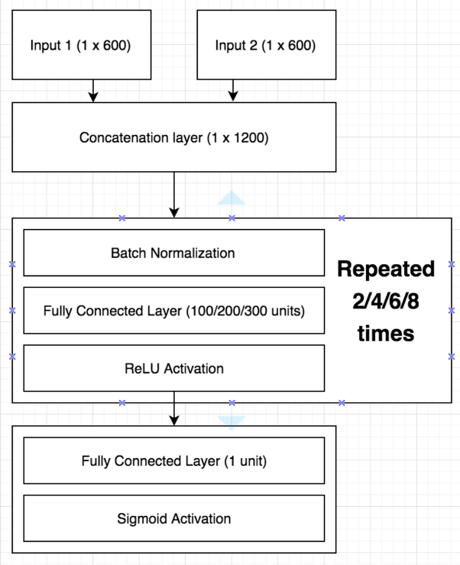

The following are the features of the model.

1. The input is provided with 2 inputs of size 1*600 of features of the question pairs.
2. These inputs are concatenated into one layer of size 1*1200 in the concatenation layer as shown above.
3. A learning unit consists of a dense layer with ReLU activation, preceded by batch normalization.
4. The final layer is a dense layer with 1 neuron and sigmoid activation. This reflects the probability that a question pair is duplicate.